Which is the Best Buy?
A Fingerpaint Experiment
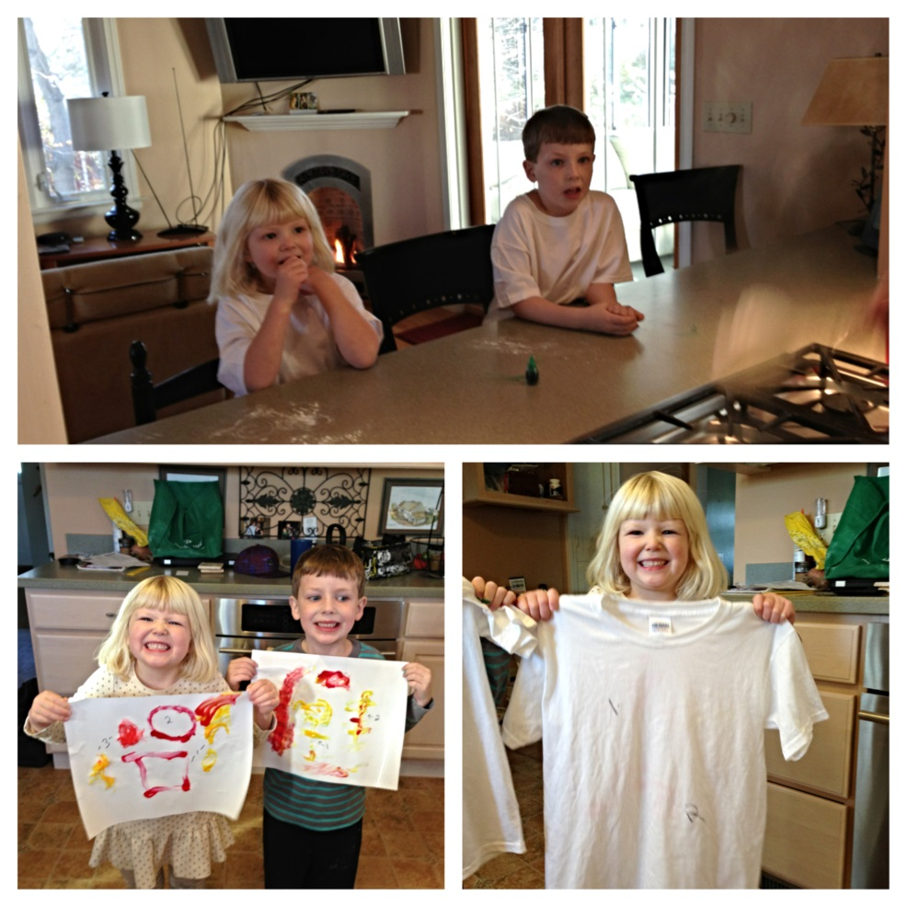
Alison Perry
EDUC 555: Science and Social Studies as Continuous Inquiry
Fall 2013
University of Saint Joseph

Which is the Best Buy?
A Fingerpaint Experiment

Objective

The purpose of this experiment is to determine which brand of fingerpaint is the best buy. The lab involved testing three elements of the fingerpaints: preference of application, consistency and vibrancy after drying, and if the paint was easily and completely washed from a 100% cotton T-Shirt. The lab was composed of three different brands. The “brands” tested in this experiment were Sargent Art, Crayola and homemade. The homemade fingerpaint was created using cornstarch, water and food coloring.

Rationale

Fingerpaint is a popular item for primary grade students to create art and/or apply their learning through visual artistic expression. Therefore, we wanted to determine the overall best buy for fingerpaints. Fingerpaint can also be expensive and used quickly, so we chose to include homemade fingerpaint, made from ingredients simply obtained from a grocery store, and use it as one of the “brands” being compared. We compared Sargent Art, Crayola and the homemade “brand” to determine the best buy. This experiment was created based on Content Standards 3.1, 3.2 and 3.4 of the Connecticut Core Science Curriculum Framework.

Variables

The variables that were tested in this experiment were preference of application, consistency and vibrancy of paint on paper after it had dried, and if the paint was easily and completely washed from a 100% cotton T-shirt.

To test for preference, students were asked to paint with each of the three fingerpaints and to provide their preference. This test shows which brand is most preferred based on the results of this test. Due to different consistencies and application, some people have a preference about fingerpaints; therefore, this test would show what the general preference of each student is without knowing the brand. This test is an opinion test, while the other two tests are based on physical experiments. The dependent variable present is brand of fingerpaint, meaning the independent variable would be each student’s preference.

To test for consistency, the students were asked to observe the consistency of each brand of paint through visual observation, touch, feel and measurement from the paper. To test the vibrancy of paint on paper after it dried, the students were asked to observe the color visually and record their findings. This mixed test represents elements of opinion and physical experiment. Again, the dependent variable present in this experiment is brand of fingerpaint, while the independent variables include measurement and observation data collected and reported by students.

To test if the brands of paint are washable, the students were asked to paint on a white, 100% cotton T-Shirt with each of the three brands. Each brand was placed on the same T-Shirt represented an independent variable. After the paint on the T-Shirts had dried, the students then (with assistance) washed these shirts in the washing machine on regular cycle with Tide Detergent. Once the T-Shirts had been washed, students were asked to observe the pre-marked areas of the shirt for each brand of fingerpaint and determine through observation of the T-Shirt if each paint had washed out completely or not, and if not, to what degree it had washed out. This test was a physical experiment based on collaborative visual observation of results. The dependent variable present in this test was the brand of fingerpaint. The independent variables were the Tide detergent, washing machine, and observation data.

Hypotheses

- Crayola will be the easiest to apply. This hypothesis is based on the reputation of Crayola as a well-known, comprehensive and user-friendly art brand. Crayola fingerpaint also comes out of the tube with a smooth and thick consistency that appears easy to work with. Sargent Art will be the second easiest to apply. This hypothesis is based on the professional reputation of Sargent Art; it will be fairly easy to apply, but the point of this paint is to provide more professional results. This is also based on the consistency of the fingerpaint in the containers. The homemade “cornstarch” fingerpaint will be the hardest to apply. This is based on the inexpensive and creation that was homemade and not created by a professional, and the thick, globby consistency on the plate.

- Sargent Art will have the best consistency and vibrancy. This hypothesis is based on the vibrancy of the colors of the Sargent Art paints both in the container and on the plate. Sargent Art also has a reputation of being a more professional brand, and is the most expensive among the brands, and so in making the prediction, we considered that Sargent Art would be most concerned with the final product that makes use of their paints. Crayola will have the next best consistency and vibrancy. This is based on the reputation of Crayola and the consistency of the wet fingerpaint before it has been applied. The homemade “cornstarch” fingerpaint will have the worst consistency and vibrancy. This is based on the low price and homemade element of the creation and the thick, globby consistency when observed on the plate.

- Crayola will wash out the most quickly and completely. This hypothesis is based on past experience with Crayola products being washable. Also, we observed the word “Washable” printed in big letters on the box before the paints were separated into their blind numbers. Since Crayola is a reputable company, they would likely stand behind such a promise, especially since it is one of the specific points being used to market the product. The Sargent Art fingerpaint will be the second most washable. This is based on the fact that, after searching and observing the packaging, the word “washable” is listed in small lettering. Due to good reputation of Sargent Art, we believe that they will follow through on this promise. The homemade cornstarch-based paint will be the least washable of the three brands, and may not wash out at all. This is based on the use of food coloring in this paint. Although cornstarch and water would likely wash completely out of the cotton T-Shirt, the food coloring is essentially a very concentrated coloring agent, with the stated purpose of permanently coloring food and other items.

Required Materials
- 1 package of Crayola Fingerpaint
- 1 package of Sargent Art Fingerpaint
- 2 cups of Cornstarch
- 4 cups of Water
- 2 Plastic cups, to mix the cornstarch and water, with spoon
- Pot
- Stovetop, to boil water and cornstarch mixture
- Red Food Coloring
- Yellow Food Coloring
- 3 paper plates, to present the fingerpaint as three unidentified brands
- Art Paper
- White Cotton “Mad Scientist” T-Shirts (for the washable test)
- Small ruler with ‘mm’ markers
- Permanent Marker to mark each fingerpaint by number on the plates, paper and T-Shirts
- Timer
- Tide Detergent
- Paper and pencils (to record data)
Procedure
Note: Before the actual “Best Buy” portion of the experiment begins, students will complete an experiment mixing cornstarch and water, and observing the teacher boiling these substances to make a new substance. Teacher will not have told the student the purpose of the experiment and students will have engaged in inquiry and experimentation to determine the properties of the new substance, and, later, that the purpose of the experiment is to create fingerpaint. Students will mix the newly formed fingerpaint with food coloring to create a usable color fingerpaint. This experiment must occur separately so that teacher can place and number homemade fingerpaint on the paper plates; students must not know which of the three fingerpaints is not commercial to yield accurate results.

Post-Fingerpaint Creation Experiment Preparation:
- Clear off your surface and put everything away except for your science lab notebook and a pencil. It is important to have a clean surface to work with.
- Before starting the experiment, please read through the rest of the procedure so that you are aware of what will be happening and what you will be doing.
- Gather the materials listed below:
- Three plates with fingerpaint placed on it, each a different number. Note: Each plate will have two colors of fingerpaint on it. The plates will be labeled with a number written on the plate. Plate 1 is Sargent Art brand fingerpaint, plate 2 is Crayola brand fingerpaint, plate 3 is homemade (cornstarch, water and food coloring) fingerpaint. *Students will not know which brand is which so that the results remain consistent. *
- One piece of art paper for each partner.
- One white cotton “mad scientist” T-Shirt per person.
- One plastic cup for each scientist.
- One container of red food coloring
- One container of yellow food coloring
- One small ruler with ‘mm’ markers
- Timer
- Packet of data tables
- Once all of the materials are collected go back to your surface and make sure that you have all of the materials listed above. Check again to make sure that your three paper plates represent different numbers: 1, 2 and 3.
- Put on your “mad scientist” T-Shirt and wear it throughout the experiment until it is needed for the Washable Test later in the experiment.
- Make sure you use the appropriate data table for each of the experiments. Collect and write your data on the tables in your science packet.

Preference Test
- You will be using your art paper, each of the three paper plates with fingerpaints, and your science packet, paper and pencil to record data. You will also need the timer close at hand, as it will be used to facilitate movement from the Preference Test to the Consistency and Vibrancy after Drying Test.
- Place your art paper on a flat surface.
- Starting with the paper plate labeled 1, and moving in numerical order, begin painting on the art paper with the fingerpaints. Note: Make sure that each fingerpaint is used in a specific portion of your paper, and is easily discernible and able to be labeled, as this paper will be used for a later experiment.
- As you use each fingerpaint, make observations and take notes as to what you like and dislike about each fingerpaint, in preparation for reporting the results of the preference test.
- After you have used a brand of fingerpaint, mark in small and legible numbers which number fingerpaint is represented in each portion of the art paper.
- Repeat this same procedure for each of the fingerpaints.
- Report which of the three fingerpaints is your preferred brand on the paper and provided science packet.
- Keep a tally on your data sheet as you ask all of the subjects for their preference.
- One partner should be marking the preference and the other should be recording comments your classmates make about the different fingerpaints on the observation section of the data sheet.
- When you have asked everyone tally up the totals and see what brand ranked the best.
- When you have finished this test, make sure the supplies are picked up so that you can proceed to the next test.
- Set the timer for 30 minutes, at which time you will conduct the Consistency and Vibrancy after Drying Test.
- While you are waiting for the timer to go off, you will construct a bar graph of the preferences of fingerpaint.
Consistency and Vibrancy after Drying Test
- In this test, you will be using your art paper with paint that was created during the Preference Test, small ruler with ‘mm’ markers, paper and pencil for recording data, and the proper data chart from your packet.
- Thirty minutes after the Preference Test is completed, the timer will go off. At that time, retrieve your completed art paper from the drying surface and lay it flat.
- Observe the vibrancy of the colors after drying. Make notes in your science notebook about your observations of each of the three brands, using the numbers that you marked during the Preference Test to confirm that you are noting observations about the correct brand.
- Observe the consistency of the paint after drying. Make notes in your science notebook describing the consistency of the paint, using the numbers that you marked during the Preference Test to confirm that you are noting observations about the correct brand.
- Using your small ruler, measure the thickness of the paint starting from the paper. Note if the paint has dried thickly or thinly and the measurement that you have obtained. Make notes in your science notebook about the measurements and your interpretation of that data.
- During this test, you should be writing what you are observing in your science notebook and/or the observation section of your science data packet. What do you see? What do your observations mean?
- When you have finished this test, make sure the supplies are picked up so that you can proceed to the next test.
Washable Test
- For this test, you will use your “mad scientist” T-Shirts, the three paper plates of fingerpaints, washing machine, Tide detergent, permanent marker, ruler and the data chart.
- You will prepare by standing in an open space with the fingerpaints. You will use the fingerpaint, starting with 1, and moving in numerical order, to color on your shirt. You will make sure that each brand of fingerpaint is on a separate section of your shirt so that it will be easily labeled and easily identifiable.
- After you have used a brand of fingerpaint, mark in small and legible numbers with the permanent marker which number fingerpaint is represented in each portion of the T-Shirt.
- Repeat this same procedure for each of the fingerpaints.
- Set the timer for 30 minutes.
- At the end of 30 minutes, you will check to make sure that the fingerpaint is fully dried.
- Take the shirts with the dried fingerpaint to the washing machine, and, with assistance from teacher, place in washing machine and begin a regular cycle, using Tide detergent.
- After the wash cycle is over, remove T-Shirts from the washing machine and place on a flat surface.
- Observe whether there is any paint, or remnants of paint, on the T-Shirt. Report observations in science notebook and/or observation section of your science packet.
- If paint or a stain is observed, use ruler to measure the size of the paint or stain, and record observations.
Overall
      - Return all supplies to the front counter.
      - Wash hands and clean up your surface.
      - Using the data collected from your own experiment, you will create a conclusion chart to determine which brand of fingerpaint is the best buy.
      - Complete the reporting of data in the observation section of the science packet.
      - Construct the appropriate graphs and lab report to display this data.
Data/Observations
Procedure 1 (Preference) Observation Data:
 | Properties Observed by Scientist/Group #1 in Application of Fingerpaint | Properties Observed by Scientist/Group #2 in Application of Fingerpaint
1 – Sargent Art Fingerpaint | - “Too wet”  - “Hard to draw with” | - “Great”  - “Favorite”  - “Easy to draw with”
2 - Crayola Fingerpaint | - “A little wet” | - “Good”
3 – Homemade, Cornstarch-based Fingerpaint | - “Mushy”  - “Easy to spread”  - “Easy to paint with” | - “Mushy”  - “Squishy”

Observations: Students enjoyed this test very much because they got to use fingerpaints to create their own unique art. Students seemed to be very excited to engage in the novelty of really thinking about and talking through what they liked and disliked about each of the fingerpaints. Recording data observations was exciting for the students, as well. Students took the task of choosing their favorite brand of fingerpaint very seriously, considering each element of their reported observation.

Procedure 2 (Vibrancy after Drying) Observation Data:

 | Properties Observed by Scientist/Group #1 in Application of Fingerpaint | Properties Observed by Scientist/Group #2 in Application of Fingerpaint
1 – Sargent Art Fingerpaint | - “Bright” | - “Easy to see what I painted”
2 - Crayola Fingerpaint | - “Bright”  - “Thick and dark enough so I can see everything I drew” | - “Very dark and pretty colors”
3 – Homemade, Cornstarch-based Fingerpaint | - “Pale” | - “Not as dark as the other paint”

Observations: Students enjoyed this test, but not as much as they enjoyed the initial test measuring preference or the other portion of this test, measuring the consistency after drying. I believe that the reason that students were not quite as engaged in this portion of the experiment is because they were simply observing and describing, and didn’t have to do much other than report data. In the first test, the students were actively engaged in the use of the product, which kept their attention. They did seem to enjoy thinking about and giving reasons for their observations, but were much more engaged in the consistency measurement portion of this test, likely because they were able to measure with a real “tool.”

Procedure 2 (Consistency after Drying) Observation Data:

 | Thickness Measurements | Properties Observed by Scientists as to Consistency
1 – Sargent Art Fingerpaint | 2 mm | - “the same all the way across (consistent)”  - “almost dry”
2 - Crayola Fingerpaint | 1 mm | - “smooth”  - “dry”
3 – Homemade, Cornstarch-based Fingerpaint | 5 mm | - “globby”  - “bumpy”  - “hard to see what it is”  - “still wet”

Observations: Students enjoyed this test very much. Students were excited to use a tool, specifically, a ruler, to measure the thickness of the consistency of each paint. Students were engaged in using descriptive words to talk about the consistency of the paint as dried, and tied together their physical results (the real measurements) with their observations. It was fairly difficult to measure the thickness of the paint for at least brand numbers 1 and 2, but important data was gathered as to the thickness of brand number 3. Students again took their task very seriously and recorded and interpreted the data as a team.

Procedure 3 (Washable) Observation Data:

 | Stain Measurement (Diameter) | Properties Observed by Scientists as to Stain
1 – Sargent Art Fingerpaint | 2.75” | - “More faded than the other stains”
2 - Crayola Fingerpaint | 1.25”, 1.75”, 2.5” | - “Light, but dark enough to see if you are looking.”  - “Darker than the stain from fingerpaint #1.”
3 – Homemade, Cornstarch-based Fingerpaint | N/A

Observations: Students enjoyed both elements of this test very much. Students were excited to paint all over their own shirts and create a mess. This excitement translated into waiting to see if the paint washed out. Students were glad to be able to use their observation skills as well as the ruler as a tool once again in gathering data about whether each of the paints on their T-Shirts was washable.

Results

Comparison Test Data – Which Fingerpaint is the Best?

 | Preference | Vibrancy and Consistency After Drying | Washable
1 – Sargent Art Fingerpaint | Student #2 very clearly chose Sargent Art fingerpaint as her preference over the others; Student #1 expressed a clear preference against Sargent Art Fingerpaint. | Results provided that Sargent Art paint provided the second thinnest measurement and observation results agreed that it had the second best consistency. | Data showed that Sargent Art fingerpaint was the second most washable, leaving behind a discernible, but faded, stain on one of the two shirts.
2 - Crayola Fingerpaint | Student #1 was undecided as to his preference between Crayola and Homemade fingerpaint. | Students agreed that Crayola fingerpaint was the most vibrant and the results show that it provided the thinnest measurement and had the best consistency after being dried. | Data showed that Crayola fingerpaint was the least washable, leaving behind stains on two of two T-Shirts
3 – Homemade, Cornstarch-based Fingerpaint | Student #1 was undecided as to his preference between Crayola and Homemade fingerpaint. | Physical measurement and observation data results both place Homemade fingerpaint in last place for this test due to thick, globby paint with a faded color. | Data showed that Homemade fingerpaint was the most washable, leaving behind no remnants of the fingerpaint after being washed on regular cycle with Tide Detergent.

There was a clear disagreement as to the preference of fingerpaint. One student chose Fingerpaint #1: Sargent Art, as her clear preference. Another student could not choose a clear preference, but split his vote between Fingerpaint #2: Crayola and Fingerpaint #3: Homemade. Since the first students chose one paint, and the vote of the second student must be split into two halves, the winner of Test #1: Preference Test is Fingerpaint #1: Sargent Arts, with a tie for second place between Fingerpaint #2: Crayola and Fingerpaint #3: Homemade. Therefore, our hypothesis for the Preference Test was incorrect.

There was a clear agreement based on observations and measurements as to the fingerpaint that was the most vibrant and had the best consistency after drying. The winner of Test #2: Vibrancy and Consistency after Drying is Fingerpaint #2: Crayola. The measurement data showed that Crayola was the thinnest and lightest paint after drying, yet visual observation data showed that it was also the most vibrant. The measurement data and observation also consistently showed that Fingerpaint #1: Sargent Art was the second most vibrant paint and had the second best consistency, therefore securing second place on this test. Data shows that Fingerpaint #3 had limited vibrancy and overly thick, globby consistency, and therefore places in third and last place on this test. Therefore, our hypothesis for the Vibrancy and Consistency after Drying Test was incorrect.

The clear winner of Test #3, which asked which paint was most washable, was Fingerpaint #3: Homemade. Fingerpaint #2: Crayola left light red stains on both of the T-Shirts that were tested, and therefore comes in third place for this test. Fingerpaint #1: Sargent Art left a discernable light red stain on one of the two T-Shirts, and therefore comes in second place for this test. Therefore, our hypothesis for the Washable test was incorrect; in fact, the paint that we hypothesized would be the most washable was in fact the least washable.

Conclusion

 | Sargent Art | Crayola | Homemade
Test 1 – Preference | 1 | 2 | 2
Test 2 – Vibrancy/Consistency | 2 | 1 | 3
Test 3 – Washable | 2 | 3 | 1
Total | 5 | 6 | 6

The overall fingerpaint best buy in this experiment was Sargent Art Fingerpaint. We were able to determine this result through the use of three experiments. We tested preference, vibrancy and consistency after drying and whether it was washable on three brands of fingerpaints: Sargent Art, Crayola and Homemade. Our hypotheses for each of the three tests were incorrect.

Sargent Art fingerpaint, which was the most expensive, was also the one that we had hypothesized would create the best final product. While it did not win the Vibrancy and Consistency after Drying test, it did win as the overall best buy. Crayola fingerpaint, which was the second most expensive, tied with Homemade fingerpaint for second place. Homemade fingerpaint is extremely inexpensive, and so it is important to note that it tied for second place and ranked only one point below the first place finished, Sargent Art. The preference test, however, represents one third of the score and preference may vary greatly among users.

Students enjoyed completing this experiment very much. They especially enjoyed mixing the ingredients to create the homemade fingerpaint, but they also were very actively involved in collecting and interpreting data to choose the best fingerpaint. One student stated that his favorite part was watching the homemade mixture become fingerpaint, and the other stated that her favorite part was testing the shirts by painting and washing them. Both students commented that they enjoyed doing science experiments and would like to do one again soon.

